Review Questions – Endocrine and Circulatory Systems

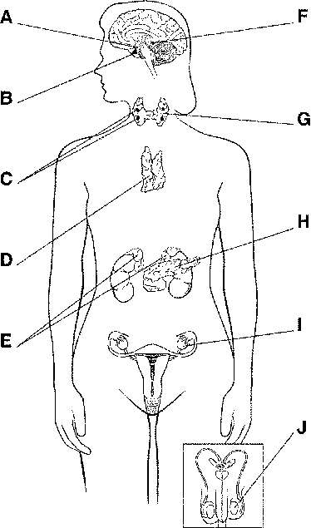
Figure 39-1

1) Figure 39–1 shows the body’s
a. hormones. c. endocrine glands.
b. target cells. d. exocrine glands.

2) What is the function of the structure labeled H in Figure 39–1?
a. to produce sex hormones c. to produce insulin and glucagon
b. to produce thyroxine d. to produce thymosin

3) Which structure in Figure 39–1 is this hypothalamus?
a. A c. C
b. B d. D

4) Which structure in Figure 39–1 releases hormones that regulate many of the other endocrine glands?
a. B c. H
b. D d. J

5) Which of the following is correct about the composition of plasma?
a. It is 90 percent water. c. It is 10 percent water.
b. It is 50 percent water. d. It contains no water.

6) Which of the following is NOT a function of blood?
a. regulate filtration c. transport nutrients
b. regulate body temperature d. fight infection

7) Which of the following is consistent with Type 1 Diabetes?
a. rapid onset before age 15 d. a and b are correct
b. frequent dosage of insulin needed e. all are correct
c. can be managed by diet and exercise f. none are correct

8) The endocrine system
a. affects only the reproductive system.
b. releases hormones into the bloodstream.
c. competes with the nervous system.
d. is made up primarily of glands with ducts.

9) Which is the correct direction of blood flow?
a. right atrium → right ventricle → pulmonary artery
b. right atrium → left atrium → pulmonary artery
c. left ventricle → pulmonary artery → aorta
d. left ventricle → left atrium → aorta

10) Name and describe the three layers of blood vessels. You will need use the correct term for each that begins with tunica.

